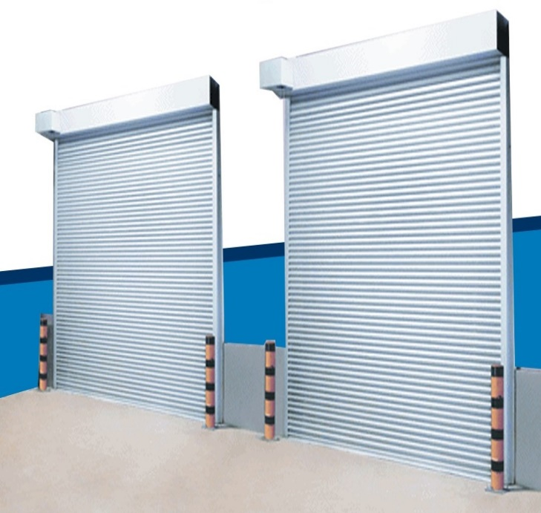
Motorized Rolling Shutter
NIHVA Provides the solution for warehouses, garages, and various industrial facilities where quick and efficient access to the opening is necessary.
The “NIHVA rolling shutter” design allows for easy control of the doorway, promoting convenience and security in a variety of applications.

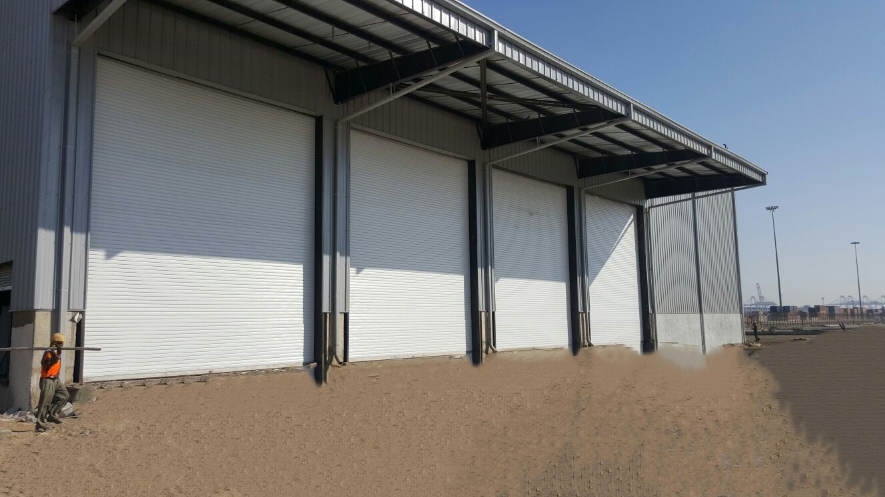
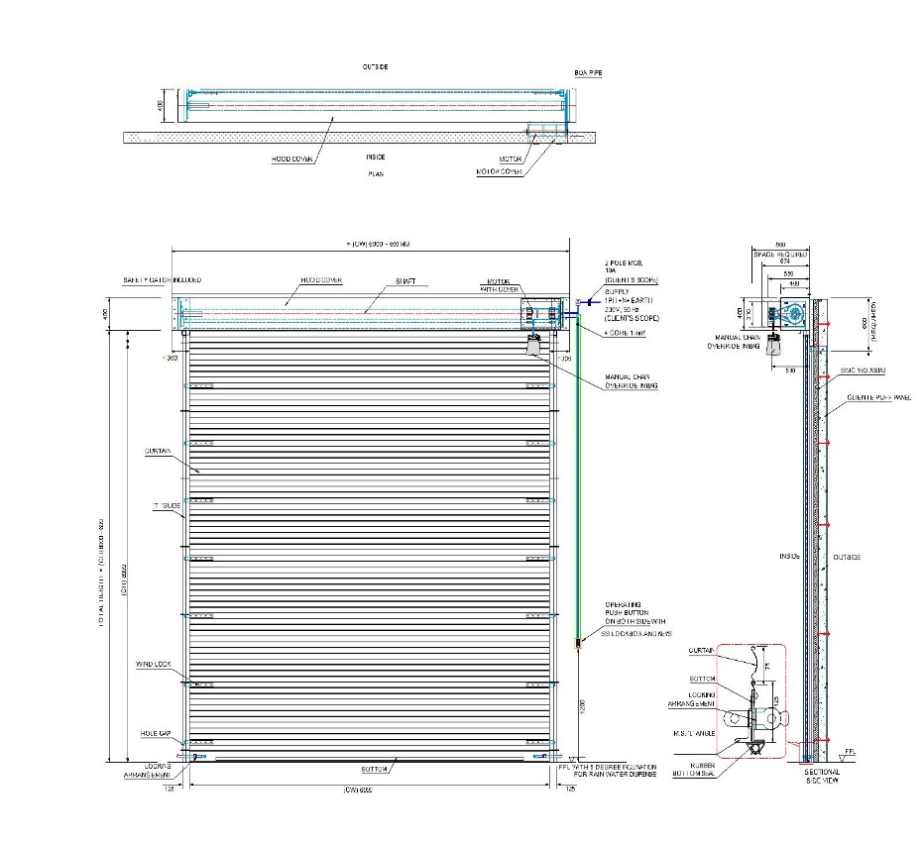
General Drawing
Door type | Motorized Rolling Sutter
Clear Opening dimension | Depends upon dimensions.
Opening Direction | Vertical - from bottom to Top
Mounting Location area | Inside/Outside Area
Mounting Surface | Side Brackets: Optional = On Concrete /Steel & Side  Guides : Optional = On Concrete/Structure / Masonry
Opening/Closing Speed | 3.3 to 5 rotation/min.
Door Material
Curtain material | GI , MS, Galvalume
Curtain Panel | The panel made of min. 1.0mm thick.
Curtain panel size | 75mm wide
Curtain Profile | Corrugation/Flat
Slat Thickness | 1.0 mm to 1.2 mm (As per IS 6248)
Bottom Profile | M. S. Plate 100 mm x 2.5 mm thick with angle stiffener
Side Guide Profile | M.S." U" Shaped profile 65 mm -150 mm x 3 mm thick (as per the opening width dimension)
Roller Shaft | M.S. Tubular Pipe with Flange & machined shaft at the ends Pipe Dia -100 to 300 mm as per w x h
Side Brackets | MS Plate 3 mm to 10 mm thick , as per the opening dimension
Hood Cover | Made of GI Sheet Thickness 0.9 mm with 25x25x3mm angle stiffener
Surface finish
Painting | 2 Coats (each coat of 35 microns DFT) of EPOXY polyamide based enamel finish of approved colour and make over a Coat (each one coat 25 microns DFT) of EPOXY polyamide based red oxide zinc phosphate primer
Options Available | Perforation in Slat Profile / honeycomb Grill
Technical Specification
Control Type | Optional = Dead man / Pulse Control
Drive Unit & Mounting Type | Option 1) Electric Motor (Imported German Make) (Single Phase/Three Phase) - Direct Mounting on Shaft.  Option 2) Electric Motor (Imported make) (single phase / three phase) - Indirect Mounting - Sprocket chain arrangement
Emergency Operation | Option = Manual Hand Driven / Chain Wheel Drive
Operating Switch | Option = Push Button from inside / Outside also.  Option = Push Button / Key Switch From Outside
Integration options | Option = Need to interlock or integrate with other door or machine or Equipment
Accessories | Option = Flashing Light / Safety Photocell  Option = Remote Control with receiver
Automation:

